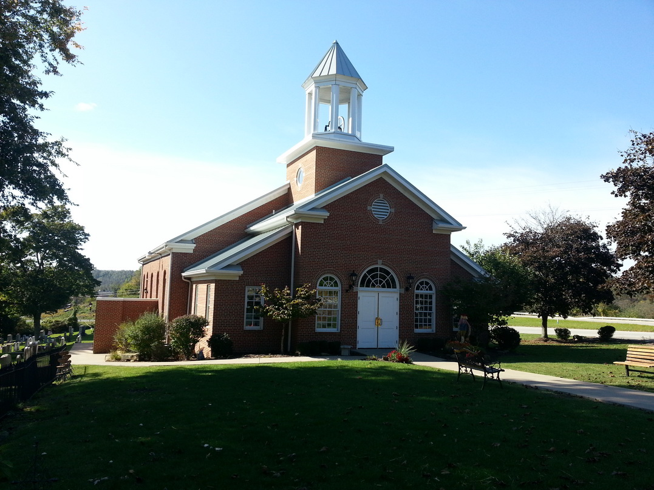

Chartiers Hill United Presbyterian Church …a historic church with a Christ-led future

March 2020

**__________________________________________________**

**The Poverty of Our Lenten Season**

More and more people bear the ash cross on the forehead to begin the journey through the Lenten season of the Christian Church. Not too terribly long ago, the gray smudge on the foreheads of our neighbors, coworkers, and strangers let us know who was Catholic and who was Protestant. Today, receiving the ashes on one’s forehead is no longer strange, even for Presbyterians. I have seen this in the past as a good thing. Our lack of ritual sometimes makes me feel like the poor step-child of the Christian faith.

Lent is the season of repentance and soul-searching. Self-examination and confession are good for the soul – literally and figuratively. There is cathartic relief in these practices. King David of Israel recognized this. David said that to abstain from confession was tantamount to a slow, painful death: “For when I kept silent, my bones wasted away through my groaning all day long. For day and night your hand was heavy upon me; my strength was dried up as by the heat of summer” (Psalm 32:3-4). In terms of our sin, silence will mean suffering. But the moment we open our hearts and our mouths and confess our guilt, we receive healing. “I acknowledged my sin to you, and I did not cover my iniquity; I said, ‘I will confess my transgressions to the LORD,’ and you forgave the iniquity of my sin” (verse 5). Although our own Ash Wednesday service had to be canceled this year, leaving me with no ashes on my head, I’ve spent some time considering the actual wearing of ashes.

**Watch Out Christmas & Easter!**

It is commonly recognized that in the Roman Catholic Church the Ash Wednesday Mass is more popular than any other day in the Christian calendar—surpassing even Christmas or Easter. That’s a staggering thought to this pastor: a day that could fill the church pews more so than Christmas or Easter? How can that be? Well, it is not that surprising if you stop and think about it. On Ash Wednesday, unlike these other holy days, you actually are *doing* something. There is a tangible participation in the worship—perhaps more appealing is the visible *demonstration* of piety. Is it surprising that law-wired sinners would flee to something like this? Going to church on Christmas to hear that the King has come, or on Easter to hear that the King has conquered, pales in comparison when you can where a badge that says you belong to that King.

As much as I too look forward to the mark of the cross, drying crustily on my forehead, I’ve grown cautious. And I found a kindred thinker in Carl Trueman, who joined the faculty of Grove College in 2018. Prof. Trueman observes that Ash Wednesday “speaks of a certain carnality: the desire to do something which simply looks cool and which has a certain ostentatious spirituality about it. As an act of piety, it costs nothing yet implies a deep seriousness. In fact, far from revealing deep seriousness, in an evangelical context it simply exposes the superficiality, eclectic consumerism and underlying identity confusion of the movement.” And that may be the underlying motives of the human heart.

What can we do? Well, with or without ashes on our foreheads, we must understand the difference between putting our spirituality on display without the true presence of the Spirit, and simply having the true presence of the Spirit in our lives.

As one Presbyterian minister puts it: Lent (without ashes) presents a healthy challenge for the Presbyterian as it provides “an opportunity for us to turn once again to God’s simple, unremarkable, and ordinary means of grace, and to put our faith in finding God where He promises to show up. These means have no flare, no attraction, and nothing about them would turn the heads of the public. But they do have Christ. In simple word, sacrament, and prayer we receive Jesus, really and truly. Isn’t that enough?”

Yes. I think it is enough. Just some things to think about during the next 42 days.

See you in church ~ Peggy

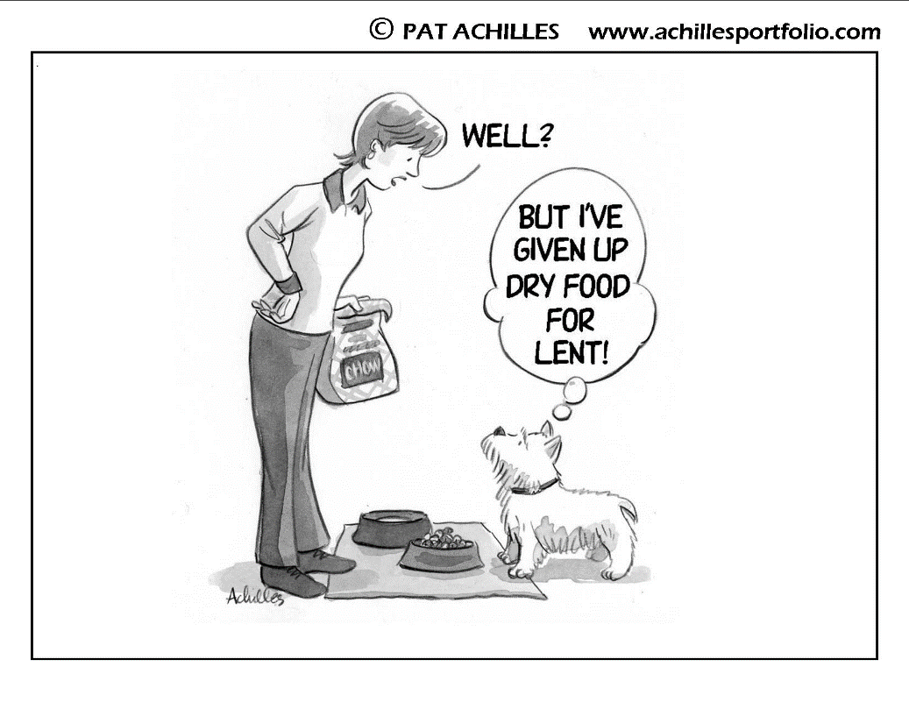



**WAKEY, WAKEY, EGGS ‘N’ BAKEY!**

**DON’T FORGET TO CHANGE YOUR CLOCKS!** **Move your clock FORWARD one hour on March 8th, 2020 at 2 a.m. or before you go to bed on Saturday night. We’ll see you at church minus one hour’s sleep.**

**INTERESTED IN CHURCH MEMBERSHIP?**

If there is enough interest, an **Adult Inquirer’s Class will be planned for Monday evenings beginning March 16th in the church ladies Sunday School room from 7:00-8:30.** Anyone who would like to know more about the Christian faith, Presbyterianism, and Hill Church in particular are invited to meet with Pastor Shannon for the first steps in preparation for church membership. These meetings are informal and no one is obligated to join the church following completion. Attendance at all three classes is required. We hope to answer questions, get acquainted, and discern the Spirit’s guidance. If you have questions and/or are interested in meeting, please contact Pastor Peggy through the church office by March 9th. **Church membership won’t magically give you peace, but it certainly can help.** After analyzing data from over 20 countries, Pew researchers concluded in 2019 that people who regularly participate in religious congregations tend to be happier and more civically engaged than their peers who are infrequent attendees or who don’t identify with a religion at all.

**WORSHIP NEWS**

**THE LORD’S SUPPER** **will be celebrated on Sunday, March 1st at both services**.

In our tradition, anyone is welcome to partake of the Holy Meal. If your children are taking part, please make sure that they understand the meaning of the Lord’s Supper. If you are not sure how to explain this – or don’t understand it yourself, please speak to Pastor Shannon, who would be delighted to help you.

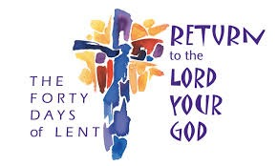

**Prayer Shawls** are dedicated on the first Sunday of each month. These shawls are made by our own members and are distributed to those who are sick or newly homebound. They are given to people anywhere who might benefit from this symbolic wooly hug from God. They are a blessing and a comfort.

**LENTEN PREACHING SCHEDULE**

Pastor Shannon will be using the epistle lessons from the lectionary during the Sundays of Lent.

March 1 -Romans 5:12-19 March 29 -Romans 8:6-11

March 8 -Romans 4:3-5, 13-17 April 5 -Philippians 2:5-11

March 15 -Romans 5:1-11

March 22 -Ephesians 5:8-14

**MUSIC DIRECTOR**



[This Photo](https://informationaction.blogspot.com/2012_12_01_archive.html) by Unknown Author is licensed under [CC BY-SA](https://creativecommons.org/licenses/by-sa/3.0/)

The Personnel Committee continues to advertise for and review resumes for the Music Director’s position. Please share that with anyone you know who might be interested. Details can be found on the website. Meanwhile, we are grateful to Toni Sears and Aleta Starkey for providing for our needs on Sunday mornings. They are gifted ladies!

God is spirit, and those who worship him must worship in spirit and truth. ~ John 4:24

**THANK YOU!**



[This Photo](http://www.mymanyconfessions.com/fantastic-gymnastics/) by Unknown Author is licensed under [CC BY-NC-ND](https://creativecommons.org/licenses/by-nc-nd/3.0/)

The Church has received a thank you note from Lois Koci for all of the kindness and care you showed her and her family upon the death of Ed.

“…Truly I tell you, just as you did it to one of the least of these who are members of my family, you did it to me.” ~ Matthew 25:40

**SERVING THE CHURCH**

**CLERK OF SESSION:** Jack Snodgrass

**ELDERS:** Jamie Bails-Richardson, Nancy Magera, Jeff Messerly, Kandi Norvell, Phyllis Sams, Mary Anne Smith, Jack Snodgrass, Tom Sokol

**DEACONS:** Sue Barkhoff, Marcia Bock, Nancy Hofrichter, Audrey Ligato (Treasurer), Dan Ligato, Emily Neill, Linda Neill (Moderator), Sue O’Bryon, Ann Puchany (Secretary)

**TRUSTEES:** Sean Beckwith, Lafe Decker (Treasurer), Jim Drake, Lori Jarosh, RoseAnne Messerly, MaryLee Neill (President), Richard Neill (Vice President), Kenny Polk, Gary Woodruff – no secretary named yet.



**COMMITTEES OF THE CHURCH**

**AND CURRENT MEMBERS**

Elders, Deacons, and Trustees all volunteer to serve, not on their respective boards, but also on the committees of the church. The work is vast and there exists opportunities for all members of the congregation to share in it, to find a place where interests and skills can make a happy collision for the kingdom of God here in our church. Below are listed committees of the church and current membership. You are welcome, in fact you are encouraged to find a place of your own here. Contact the chair of any committee or the church office and we will get you plugged in to where God can use you. Please pray for the Spirit’s leading in your discipleship. Following are officers serving on church committees. As of this writing the Trustees have not made those decisions.

**Christian Education:** Phyllis Sams & Mary Anne Smith (elders), Marcia Bock, Emily Neill, Linda Neill (deacons)

**Evangelism:** Jeff Messerly (elder), Audrey & Dan Ligato (deacons)

**Mission:** All elders, Nancy Hofrichter & Ann Puchany (deacons) *…..continued on next page*

**Personnel:** Jack Snodgrass (elder), Sue O’Bryon (deacon)

**Worship:** Nancy Magera & Tom Sokol(elders), Sue Barkhoff (deacon)

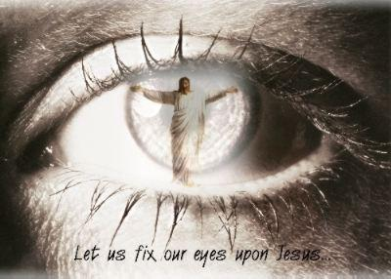**SERVING THROUGH GIVING**

**PER CAPITA:**

Thank you to those members who have already paid their per capita for the year 2020. Each dollar paid by church members saves a dollar from our general fund for mission and ministry. The per capita envelopes were printed prior to the new per capita amount being established. If you’ve already made your payment, the Budget and Finance Committee appreciates it. If you haven’t paid your per capita yet, please make your donation in the amount of $45.00. Regardless, the church and community are blessed by your giving. The per capita monies fund not just staff and office equipment for the Presbytery, Synod and General Assembly, but also give much needed financial support to local missions and Pine Springs Camp.

“Each of you must give as you have made up your mind, not reluctantly or under compulsion, for God loves a cheerful giver.” ~ 2 Corinthians 9:7

**FOCUS ON FELLOWSHIP, FUN, AND MISSION**



**MARCH SOCIAL on March 8th following the 11:00 worship service**

The theme is St. Patty’s Day – please bring a side-dish or dessert to share. The meal is hosted by the Christian Ed. Committee. There is no famine - we promise more than boiled potatoes!

**INTERNATIONAL DINNER**

**SATURDAY, MARCH 28, 2020 / TIME 4:00 – 6:30 PM**

**Thomas Presbyterian Church – 1068 Linden Road, Eighty Four, PA**

**BENEFITS THE HILL CHURCH BUILDING FUND**

Contact: Jamie Richardson 724-255-7972 jamie.bails@bailsllc.com

**Tickets:** $10 which includes spaghetti dinner & 2 international sides/dessert

Additional food tickets are available for purchase. Beverages are provided at no additional cost.

**What else?** Baskets and Silent Auction, entertainment, themed baskets for raffle and a silent auction.

There are SOOO many ways to get involved in this wonderful event. Donations are needed for the auction, table sponsors are needed, donations of food, themed gift baskets for the raffle, sell tickets, help set up, serve, clean up. Following is a list of important information and you are encouraged to email or call Jamie Richardson (see contact information above) with further questions.

* Decorate your 6 ft ROUND table for the nationality you selected. Ideas include décor, small gifts, things for guests to wear, etc. Jamie will have a flag for your table with your country name.
* You do not need to bring snacks or food for your table – only the 4 dozen item contribution for the ‘side/dessert’ tables. Food should be present by 3:30, in single serving sizes.
* We will have disposable paper products and silverware in a neutral color. We will also have ‘to go’ containers.
* You are asked to try to sell your 10 tickets including your own. If you cannot, they will return to the 'pool' March 1st for general sale.
* Set up will be Saturday, April 6th at 1:00pm.
* Basket drop off will be by Saturday, April 6th at 1:00pm.
* Ticketed guests will begin arriving by 4:00pm.
* Volunteers can choose or will be assigned to Shift 1 (3:30-5:00) and Shift 2 (5:00 - 6:30).



**The tentative schedule is:** 4:00 Welcome and Announcements

4 - 5:00 Main Meal, Praise Band

5:00 Return Thanks, Announcements

5:15 - 6:15 Praise Band

6:15-6:30 Drawings, Auction Awards

Door Prizes Baskets

50/50 Drawing Silent Auction

**PINE SPRINGS CAMP:** It’s time to start thinking about sending your children to summer camp or taking a summer camp family vacation. If you are interested, information can be found at [www.pinesprings.org](http://www.pinesprings.org) or contact the church office. Pine Springs is a one-of-a-kind Christ-centered camp experience for children, youth, adults. Campers are grounded in Biblical teaching through a variety of activities. Once your child attends, they are hooked. Let’s do all we can to give them the opportunity to grow closer to Jesus Christ and understand their faith more fully. All too soon they will be grown and gone – send them into life with the best equipment you can. There are camperships available both through the Pine Springs office and the church to assist with the cost.

**ROBERT K. BYERS SCHOLARSHIP AWARDS PROGRAM**

This fund was created by Robert K. Byers by his wife, Marylyn Byers. The original amount, invested with the Presbyterian Foundation, was $10,000. The award is given each year, usually in June. As the investment pays out dividends each year, a $500 award is given to the candidate identified by the Scholarship Committee. There is an application process with a **deadline of April 1st**. If you are a spring 2020 graduate, please pick up the appropriate forms from the church office as soon as possible and return completed application there as well. This is a generous gift to our young people and we are grateful to Marylyn for her ongoing support of the program.

**LONG RANGE PLANNING UPDATE**

The following has been thoughtfully prepared by Rodger Rainey & Kandi Norvell in order to update you on the state of the proposed building project.

**First, the important things:**

* The Long Range Planning committee would like to assure everyone that the funds raised for the building fund will be used only for that purpose: preparation and construction of the structure.
* We would like to thank everyone for their pledge contributions and work on fund raising events and activities.

**Here is a brief summary and update:**

The Long Range Planning Committee began activities a number of years ago with regard to the eventual construction of a “multi-purpose building” for the replacement of our current educational building. With the completion of a rendering of a proposed structure, the finance committee (specifically for the financing of the new project) was formed and the church held a capital campaign in 2014.

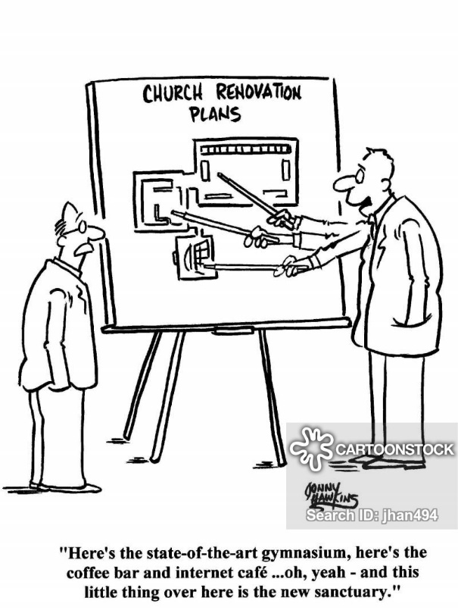In addition to the capital campaign, numerous fund-raising activities have taken place for the specific purpose of building our capital. These activities include Golf Outings, International Days, Clay Shoots, the sale of birdhouses, jewelry, cookbooks, and t-shirts. We’ve hosted Strawberry Festivals, Flea Markets, auctions, and plant/flower sales. A portion of the proceeds of each of these was dedicated to the building fund. There have been special “envelope fundraisers.” Thank you to everyone for your support, hard work and contributions.

Total building fund assets collected through the capital campaign and the other fundraising efforts is $448,024 dollars. These funds are ear-marked, placed into a special budget account and not useable for any other purpose than to move forward with the building project. .

We do not currently have adequate funds to start building. However, as a church body our commitment to the construction of the multi-purpose building remains a priority. We believe firmly in God’s timing and trust that the time will come to move forward.

Those listed as part of the Long Range Planning Committee are: Kandi Norvell, Mary Anne Smith, Lafe Decker, Sarah Kraski, Lynn Thomas, Jamie Bails Richardson or Rodger Rainey.

**SESSION HIGHLIGHTS**

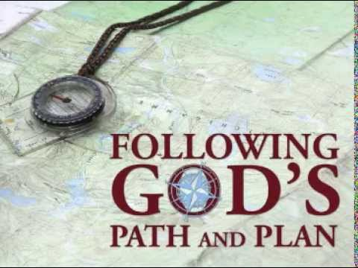**From the February 26 meeting:**

* Reviewed minutes of January meeting
* Received Pastor’s, Deacon’s, Christian Ed., Evangelism, Budget & Stewardship, Nominating, Personnel, Mission and Worship reports.
* The financial reports indicate no immediate problems.
* Discussed a young people’s gathering at Harry’s Pizza.
* Named Kandi Norvell as commissioner to the March Presbytery meeting; Jeff Messerly as the alternate.
* Discussed financial assistance for the Fresh Start Café in Canonsburg.
* Approved annual flower sale & flea market for May 15 & 16.
* Approved a blood drive TBD.
* Elders present were assigned to committees.
* Discussed safety issues with regards to the Coronavirus. Will request Deacons keep the pews stocked with hand sanitizer. Discussed what other supplies should be stocked.
* Approved March 8, 2020 as Daisy Scout Sabbath.

**BIRTHDAYS**

