Chartiers Hill United
Presbyterian Church
2022
A historic congregation
. . .with a Christ-led future
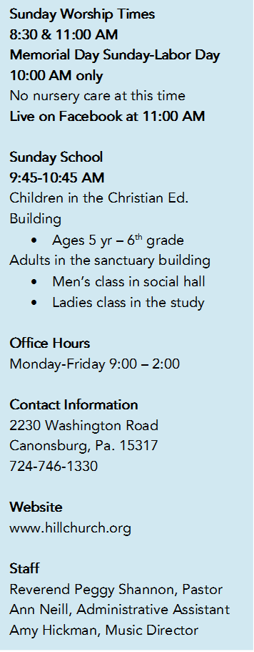
Recently my granddaughter and I had to fill an hour of time on the other side of Washington. We already had dinner and nobody needed dessert, so we went to Marshall’s at the moribund Crowne Center Mall just to walk around and kill time. Along with some leftover St. Patrick’s Day decorations, Easter was bursting out all over the store. There were bunnies made of straw, fluff, fabric, glass, ceramic. Some were covered in fake plastic greenery. There were eggs of every color and size. There were bunnies pushing carts full of eggs and bunnies playing on a seesaw. There were fake carrots everywhere made from papier-mâché, fabric, pottery, plastic…and Easter wreaths. There were cute paper napkins with carrots on them and Beatrix Potter characters formed a large community on shelves and display stands. A few peeps and ducks added to the retail zoo. What was NOT there, was a cross…or any sign of the real reason we celebrate Easter. Of course I understand how the bunnies and eggs became part of the lore of our Christian celebration. Still, they aren’t the main event. My little charge and I talked about what Easter really means. She’s pretty smart. Later that night I started poking around on-line to see what “the-other-kids-in-the-street” angle might be on Easter. One late night television host had done just that, asking random children in New York City about Easter. I was pleasantly surprised by how many had some small clue. One little cherub said, “He came back and did this…” throwing his arms open wide as if nailed to a Cross. A young girl knew something about two angels and a boulder that got moved. One knew that the “bad guys killed him.” Another, though, thought “the Bermans” did it. I assumed somewhere in this child’s life she’d heard about the Bereans of church history. These kids had many reasons for the existence of Jesus and his return from death: he sent toys, made bunnies, was working on a computer project in heaven before coming to earth – to see the Easter bunny. He came back to give us Easter eggs and to tell the bunnies not to hide the Easter eggs. He came back because the people wanted him to “protect us and not kill us.” And one young guy, when pressed about how Jesus died, said that drugs were the cause – how contemporary! After not knowing whether to laugh or cry, I stumbled immediately upon a website that contained a lengthy – l-e-n-g-t-h-y – article on just how long you should allow your child to believe in the Easter bunny and how to break the news to them. In the middle of this article (Did I mention it was lengthy?) came this, “And experts say there is simply no scientific evidence that belief in the Easter bunny has any long-term harmful effects.” First, did we need experts to tell us that? Second, as true as it may be, the other side of the coin is this: if we never make the effort to help our children know the real story and reason for our Easter celebration, the harmful effects can make the difference between eternal life (forever) and eternal life outside of heaven (also forever).

Romans 8:34-35: “Who is to condemn? It is Christ Jesus, who died, yes, who was raised, who is at the right hand of God, who indeed intercedes for us. Who will separate us from the love of Christ? Will hardship, or distress, or persecution, or famine, or nakedness, or peril, or sword?” No, none of that will separate us from the love of Christ. But letting our children remain ignorant of what Easter means for them might.

There is much to do, friends. Get on your knees and get busy.
See you in church,
Peggy
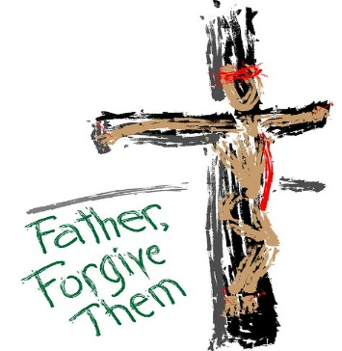
LENTEN SERMON SERIES:
THE BAD BOYS OF LENT CONCLUDES
April 3 – Pontius Pilate – The Lord’s Supper
HOLY WEEK
April 10 – Palm Sunday 8:30 & 11:00 Services
April 14 – Maundy Thursday 7:00 PM Service
April 17 – Easter Sunday 7:00 AM Sunrise Service and 11:00 Traditional Service

SUNRISE WORSHIP SERVICE 7:00 AM
Behind the Christian Education building
Bring a lawn chair
Dress for the weather
Muffins, coffee, orange juice will be served
TRADITIONAL WORSHIP SERICE 11:00 AM
In the sanctuary

THE MONTH OF APRIL
Please note changes to meeting times and dates for Mission and Budget & Stewardship meetings.
Meetings
1st Monday at 7:00 – Christian Education – Moses Room
1st Wednesday at 5:30 – Deacons – Moses Room
2nd Wednesday at 7:00 – Trustees – Moses Room
3rd Sunday of the month immediately following worship – Budget & Stewardship
3rd Wednesday at 6:00 – Mission (all elders, one deacon, one
trustee) – Moses Room
7:00 – Session – Moses Room
Every Thursday at 6:00 – Bell Choir – Sanctuary
Every Thursday at 7:00 – Chancel Choir – Sanctuary

Evangelism and Worship meet as needed or do not have a set schedule as of this printing. Nominating and Personnel meet as needed.

EASTER LILY ORDERS
Envelopes for ordering Easter lilies are in the church pews. Those must be turned into the office no later than April 3rd. The cost is $9 each. Flowers will be delivered to the church on April 8. You are invited to take your flowers home on Easter Sunday.

LENTEN DEVOTIONALS
Pittsburgh Theological Seminary provides this link to their online Lenten devotional. https://www.pts.edu/devotional_1
These daily devotionals are written by a combination of faculty, students, staff, and alumni. While you are on their website, feel free to look around. You may not know it, but if you’ve got a Bachelor’s degree you can audit a seminary course relatively inexpensively. Not all classes are open to auditors, but most electives are. Those who audit classes are not required to write papers or take exams. It’s the best of both worlds – learning without the pressure of grades!

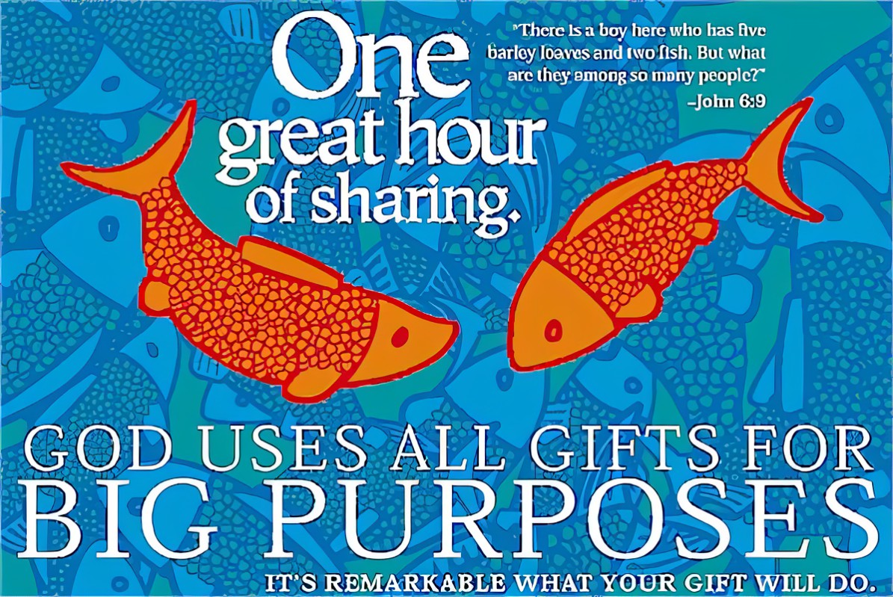
ONE GREAT HOUR OF SHARING
March 2 – April 17, 2022
OGHS is one of the special offerings of the Presbyterian Church. It is a worldwide effort in PCUSA churches to care for our neighbors in need, sharing God’s love with them through our monetary gifts. Among other things, our gifts provide relief from natural disasters, food for the hungry, and support for the poor and oppressed. There are many ways to give: by check through the church (write OGHS in the memo), online at pcusa.org/give-oghs or text OGHS to 91999. Some families use the “fish banks” (available in the narthex of the church) to collect their loose change through the Lenten season. This is a great way to teach your children about loving their neighbors.

OUR LIVE FACEBOOK FEED
As of this writing, our new computer has yet to arrive, but the live feed for March 6 and 13 were great. So, go figure. All we can say is, keep checking in. (We’d love to see you in person, too!)

COMMITTEE CHAIRPERSONS

Clerk of Session – Jack Snodgrass
This Photo by Unknown Author is licensed under CC BY-NC-ND
Budget & Stewardship – Jamie Bails-Richardson, Rodger Rainey
Christian Education – Lynn Thomas
Evangelism – Jeff Messerly
Mission – Jamie Bails-Richardson, Beth Spilak
Nominating – Jamie Bails-Richardson, Dick Holsen
Personnel – Rodger Rainey, Beth Spilak
Worship – Dick Holsen, Tom Sokol

SESSION HIGHLIGHTS FROM MARCH
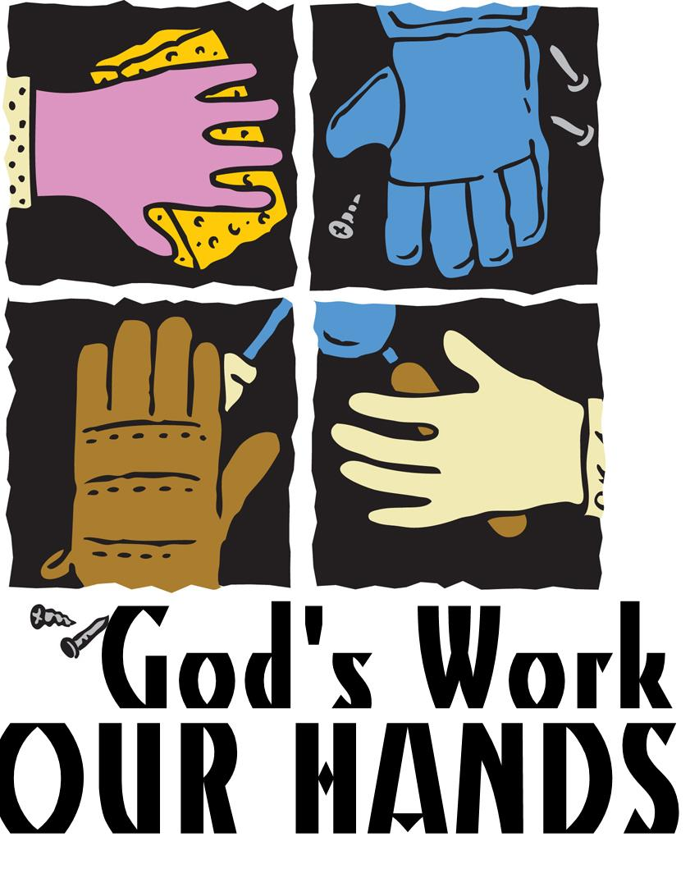
MEMBERSHIP:
- Approved the baptism of Carlin Robinson, when the way be clear
FACILITIES:
- Approved the use of our parking lot on Mondays from 3:30-7:00 (tentative) for a Farmer’s Market. The church will receive money from the use of the space
- Approved reconfiguring space in the church building to better accommodate those who have difficulty using the stairs of the C.E. building for meetings: the Women’s Sunday School room will remain their classroom, but the furnishings will change. Look forward to an upgrade to the narthex – making it a nicer place to spend time before and after services
MISSION:
- Approved a donation of $350 to Resurrection Power (a Christian based program for recovering addicts in Washington County)
- Approved the beginning of a church-to-church grant program. More information on this to come
- Approved the start of a community garden this year to grow and sell pumpkins; this will expand to other vegetables next year. The vegetables will benefit those in our community who are in need – let us know if you want to get your hands dirty!
PERSONNEL:
- Approved pastor’s vacation May 23-29 and June 27-July 4
- Staff evaluations will be moved to fall in order to better assist in the budget planning

WORSHIP:
- Approved moving the electric keyboard to behind the lectern so that the Music Director and choir are able to see one another
- Approved returning to regular Communion bread in addition to keeping the pre-packaged elements available for those who prefer them
OTHER
- Received reports from the following: Budget & Stewardship, Christian Ed, Deacons, Mission, Pastor, Presbytery, Trustees

CHRISTIAN EDUCATION NEWS

DO YOU KNOW SOMEONE WHO: Loves the Lord, loves kids, loves teaching?
Hill Church is looking for a Director of Christian Education to rebuild, reinforce, and revitalize our children’s ministries. We are ready to interview candidates who are not members of Hill Church. Pastor has a job description available. The hours are roughly: 10/week with 40 flexible hours for the summer months (June, July, and most of August).

ANNUAL EGG HUNT!
When: April 9 at 3:30
Rain Date: April 16
All children and their friends who are toddlers through grade 4 are invited. Bring a basket or bag to hold your eggs. A special Bunny will be hopping by to join us. We will meet in the parking lot at 3:30 sharp.
Donations accepted. If you’d like to donate small, individually wrapped candy, please have those at the church by April 3rd. There will be a container in the narthex to collect them. If you’d like to make a monetary donation, just put “Egg Hunt” in the memo of your check and place it in the offering plate or send it to the church office.

SAVE THE DATE! Vacation Bible School will be June 13-17, 2022

EASTER BASKETS
As in years past, Hill Church is providing Easter baskets to children and their families who participate in the local Head Start Program. At this time, we are going to fill 23 baskets. If you would like to donate money or items for the baskets, we’d love to have your help. Make checks payable to the church and put “Easter baskets” in the memo. If you’d like to donate items, the list of needs includes:
Toothbrushes Toothpaste Toiletries Candy
Infant snacks Diapers Teethers Baby Shampoo/Wash
Giant Eagle gift cards for food Food items for Easter dinner

All donations should be brought to the church narthex by April 3rd. Knowing what Jesus did for us, let us do for others as much as we can. Thank you for your loving kindness!
~ The Mission Committee

PRESBYTERY OFFICE ADMINISTRATOR is being sought to help equip the congregations and coordinate the ministries of our Washington Presbytery, serving alongside and in close connection with the Executive Presbyter. This person will need to be a self-starter possessing a broad range of administrative gifts to employ as a first contact, as a resource person, and as the organizational center of our presbytery's network of people and churches. Knowledge and experience within the Presbyterian Church (USA) will be a strong attribute. Interested persons should please send a cover letter and resume to personnel@washingtonpresbytery.org. The position is scheduled to begin on April 15.

MARCH BABIES!

