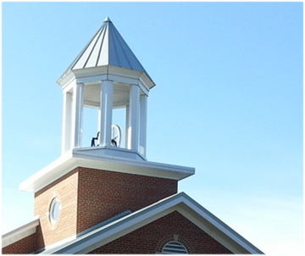
Chartiers Hill United Presbyterian Church …a historic church with a Christ-led future

April 2020

An Easter Like No Other
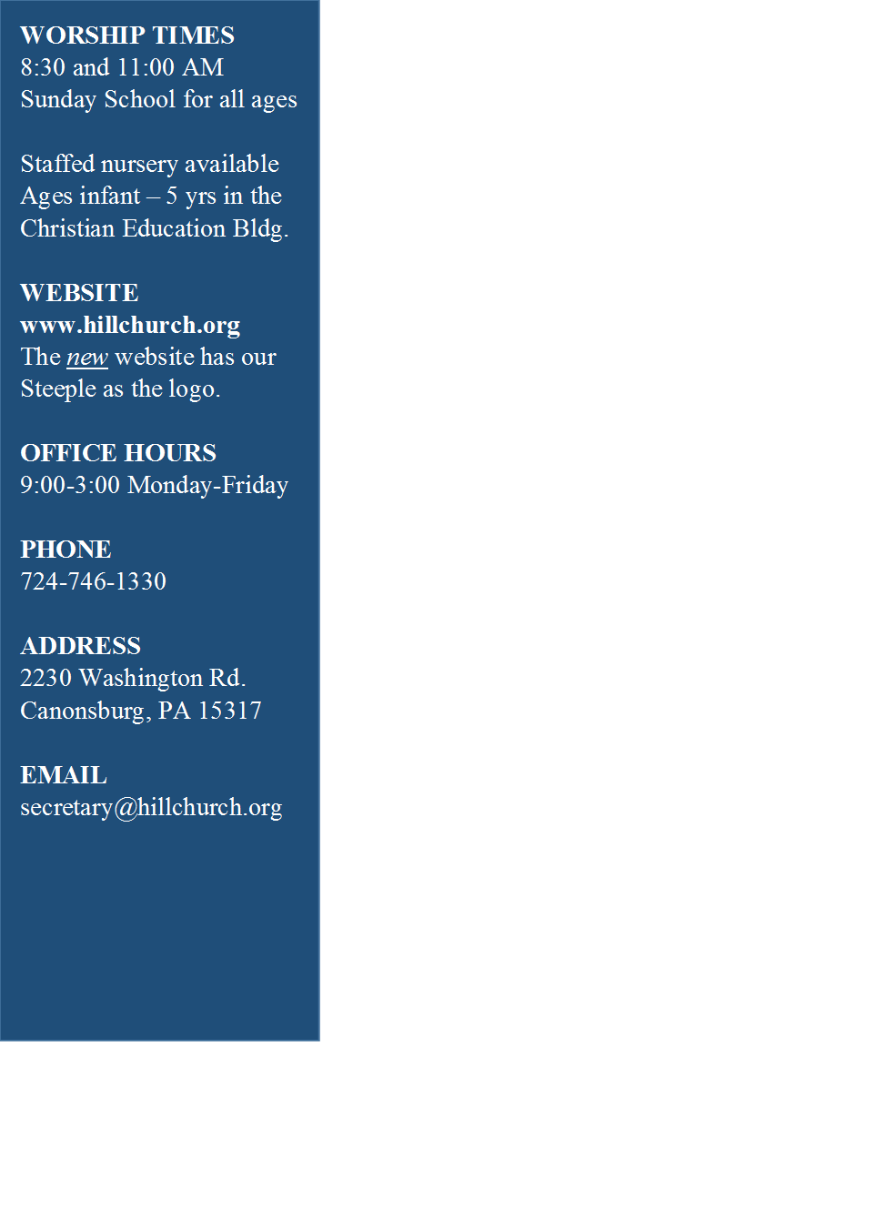
Wow! Who ever thought that we would celebrate Easter without being together – giving and receiving the peace, offering and accepting “holy hugs” from our brother and sisters in Christ? Who would think that the church would not share one bread and one cup during Holy Week? None of us saw this pandemic coming. None of us thought that it would scatter us as the Body of Christ.
Well, it almost does.
The president of Pittsburgh Theological Seminary sends out a communique to alums off and on, and I’d like to share a story he told this week:
“Several years ago I had the good opportunity to teach a course on First Corinthians at the United Theological College in Sydney. It was a week-long intensive course at the master’s level, with a few professional people and pastors as well as degree students in the class. After taking time to explore the general mess the congregation at Corinth was in—the bitter conflict between different groups, the financial and legal issues, the moral scandals—I posed the question, ‘How did Paul respond to this situation?’ I was looking for a theological answer; I had in mind the way Paul presented the cross in the early part of the letter and the body of Christ as a call to unity in the latter part. But in response to my question—'How did Paul respond?’—a pastor from the far north of Australia said, ‘He just wrote a letter.’ I was puzzled and so asked if he would say more. ‘Well,’ he said, ‘you’ve told us that Paul really cared for the people in the congregation and that they were in pretty serious trouble. But all he did was write a letter.’ The light was still not dawning on me, so the pastor continued: ‘If Paul had really cared for the people in the congregation, he would have gone to be with them, not just send them a letter. He would have gone to be present, to stand alongside them, to minister to them. But he didn’t; he just wrote a letter.’
“Over the years since then, I’ve thought often of that pastor and the genuine importance of the ministry of presence. His voice has often been in my head when I’ve pondered what to do in situations where someone is in need. ‘If you really cared,’ I can still hear him say, ‘you would go and be present.’
“But now, in the time of COVID-19, physical presence is simply not possible or, if it is, it would likely be dangerous. And so, we return to Paul and the ministry of letters, whether sent by courier, postal service, or e-mail. As so many have recognized, staying in touch, by whatever electronic or old-school means, is so very important in this time of social distancing. I encourage you: Don’t allow the requirement of social distancing to turn into emotional isolation for some. Reach out, stay in touch. Even by letter.”
David Esterline
President and Professor of Cross-cultural Theological Education
With that story in mind, I want to remind you that we are still the Body of Christ – in more ways than one. We may not find ourselves under the same roof – or the same sky, when it comes to Easter morning. We are nonetheless the flesh and bone and blood of Jesus FOR each other. Write a note, a letter, an email. Make a phone call. Drive by and wave out the windows at each other.
This Easter season will be (hopefully) like no other. What excites me in the loneliest of times is to think about the joyful celebration when we DO gather again at church and around the Table. What a day it will be to demonstrate our love for one another in person! I think of those words from Jesus’ last Passover meal:
While they were eating, Jesus took a loaf of bread, and after blessing it he broke it, gave it to the disciples, and said, “Take, eat; this is my body.” Then he took a cup, and after giving thanks he gave it to them, saying,“Drink from it, all of you; for this is my blood of the covenant, which is poured out for many for the forgiveness of sins. I tell you, I will never again drink of this fruit of the vine until that day when I drink it new with you in my Father’s kingdom. ~
Matthew 26:26-29

Those words: “I will never drink of this fruit of the vine until that day when I drink it new with you in my Father’s kingdom” keep coming back to me again and again as I think about you. Somehow, my friends, our next celebration of Communion, no matter when it may be, seems to me to be a foretaste of the ultimate gathering in eternity! O happy day!
See you on the screen!
In Christian love,
Peggy

PICK UP YOUR PALMS ON SUNDAY! From 9:30-10:00 if you drive through the church parking lot, we will be distributing your palms at the sidewalk to the church building. Take them home – we’ll learn how to make crosses from them during the 11:00 live streaming on Facebook.
In these times that seem so uncertain…
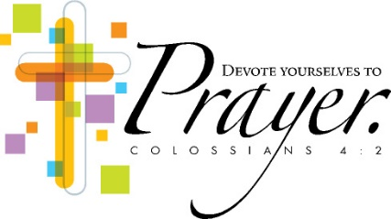
Do not worry about anything, but in everything by prayer and supplication with thanksgiving let your requests be made known to God. And the peace of God, which surpasses all understanding, will guard your hearts and your minds in Christ Jesus. Finally, beloved, whatever is true, whatever is honorable, whatever is just, whatever is pure, whatever is pleasing, whatever is commendable, if there is any excellence and if there is anything worthy of praise, think about these things. ~ Philippians 4:6-8

SESSION MEETING
On April 1st the elders held a teleconference to make plans for Holy Week, establish other policies for this time of “social distancing”, and to discuss what comes next for the month of April.
- The elders have approved a funeral policy during the time that the church must be closed due to the pandemic. We will host funeral services with not more than 10 mourners in attendance. Live streaming for larger groups may be available
- Lilies will be delivered by deacons on Friday, April 3 to homebound friends
- Elders encourage members to continue their financial support as pledged
- Once we are able to worship together again, the summer worship hours will be the same as last year: 8:30 and 10:00 from Memorial Day weekend through Labor Day weekend
- All other events remain canceled until further notice
- Elders will reconvene before the end of April to discuss future operations

Holy week
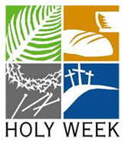
Sunday, April 5
Palm Sunday service – Facebook Live at 11:00 AM
Drive through the church parking lot between 9:30 & 10:00
to pick up your palms and say “hello”

Thursday, April 9
Maundy Thursday worship on Facebook Live at 7:30 PM

Friday, April 10
Good Friday – no services

Easter will come ~ how will you welcome it?
Although we won’t be together in church along the journey to the Cross and the Empty Tomb, Easter still arrives early on a Sunday morning. Let us shout in our hearts:

HE IS RISEN!
HE IS RISEN, INDEED!

The Resurrection of Jesus Christ is a fact that we will remember and celebrate even in our own homes. How will you celebrate? Here are some ideas:
- Dress up anyway! Put on your very best – just like you would for church. And tune into worship online or television
- Can you tell the story of Easter to your children? There are some very good children’s books:
This Photo by Unknown Author is licensed under CC BY-NC
God Gave Us Easter by Bergren & Bryant
The Easter Story by Pingry
The Very First Easter by Maier & Ordaz
He Is Risen: Rocks Tell the Story of Easter by Rokus
Max Lucado has written several

- Some fresh air might be welcome - take a ride to a local cemetery, enjoy the peace and quiet, the green grass and most of all that one day the graves will be empty because the Tomb cannot contain a living Savior
- When you hunt for Easter baskets or eggs, will you be reminded of Mary, traveling in the dark at dawn to find Jesus’ grave to sit beside it… and finding instead the beautiful sight of a Risen Lord?
- Decorate an Easter bonnet or baseball cap – everybody has to wear one! (Please – we’d love to see pictures! Post them on Facebook)
- Dye your eggs on Easter Sunday; then hunt them in your yard
- Send Easter cards – make your own if you’re creative. You can make them on Easter Sunday and when they arrive in the mail, it will remind the recipient that the Resurrection has already happened and we reap the benefits every day

This is a good year to establish a new tradition – think outside the Easter basket!

FEED MY SHEEP
Hill Church is actively engaged in the supplemental food give away that is a project of the Canonsburg-Houston Ministerial Association. Each Monday volunteers load cars and trucks with supplies, unload them at Canonsburg United Presbyterian Church on Pike Street, and pack up 200 or more bags of groceries. These bags are distributed to anyone who has a need. The hours are 1:00-3:00 at the Canonsburg UP Church and 3:00-5:00 at Holy Rosary in Muse. Monetary donations are appreciated and can be sent to: Greater Canonsburg-Houston Ministerial Association, P. O. Box 206, Canonsburg, PA 15317. This is a different outreach from the Food Bank or Food Pantry. God has blessed this outreach and it is exciting to see how God is at work in the community. Please pray for those who receive the food.

FEBRUARY 29, 2020 YEAR-TO-DATE GENERAL FUND
Total Income $57,313.62 Total Expenses $33,777.17

We are NOT in the clear. Income since mid-March is down significantly. Of course, investments are following the stock market and fluctuate greatly. Some members have pre-paid for three months to keep the operations afloat. Please continue to offer your financial support as you are able. The current news is that “shut-downs” may last through May or June. The Session will be carefully guarding our resources and watching expenses. As always, thank you for your love of Christ that opens your hearts and your hands in ways that only the Church can.
APRIL BIRTHDAYS – God bless them all!

